BRECON HIGH SCHOOL
POSITIVE BEHAVIOUR POLICY

Author | AHA
Agreed by | Governors on 21/02/24
Review Date | 02/26

1: Policy Aims:
This policy aims to:
• Provide a consistent approach to behaviour management.
• Define what we consider to be unacceptable behaviour.
• Outline expected pupil behaviour.
• Summarise the roles and responsibilities of different members of the school community regarding behaviour management.
• Outline our system of rewards and consequences.

2: School Aims:
Brecon High School aims to create a culture, climate, and ethos that nurtures the best in all of its pupils. Our ethos is built on fostering positive relationships, inspiring each pupil to 'Be the best you can be.' We operate a mutually supportive approach, underpinned by the values of Respect, Responsibility, and being Ready to Learn. At Brecon High School, we believe in teaching behaviour, with all staff expected to model desired behaviours.

3: Expectations of Pupils
Brecon High School pupils are encouraged to behave in ways that promote and embody our Core Values. We expect Brecon High School pupils to be:
- Respectful: Does the behaviour show respect to themselves and/or others?
- Responsible: Are pupils following rules and procedures?
- Ready to Learn: Are pupils properly prepared to learn (both in mindset and with necessary equipment)?
Expectations are clearly communicated to pupils (see Appendix 1).
The following behaviours are NOT expected during lessons:
- Food: All food/snacks must remain in bags until lunchtime or break time.
- Chewing: No chewing gum is allowed in school.
- Mobile phones/headphones: Brecon High School has a no mobile phone policy; these should remain in bags until pupils are out of school.
- Litter: Any mess created during the lesson must be disposed of appropriately.
The following behaviours are NOT expected around the school, outside of lesson time:
- Eating or drinking, except in designated areas.
- Aggressive or rough play: This can escalate into more serious incidents.
- Chasing in large groups: Can lead to disruptive behaviour.
- Using mobile phones.
- Being in prohibited areas.
- Littering: All litter must be disposed of appropriately.
4: Expectations of staff:
All staff should:-
- Enable a strong start to lessons by being punctual, meeting and greeting pupils, and supervising a calm exit from the classroom.
- Take the register promptly, recording and addressing late arrivals swiftly.
- Use a consistent approach in behaviour management, in accordance with the positive behaviour policy, and recognise achievement and effort using praise points.
- Demonstrate courteous, considerate, polite, and respectful behaviour at all times.
- Avoid shouting at pupils; behaviour conversations should remain calm.
- Adapt lessons to meet the needs of all pupils.
- Utilise effective questioning in lessons.
- Take responsibility for ensuring restorative conversations occur after behaviour incidents, modelling a fresh start every lesson.
5: Expectations of Parents/Carers:
Parents/Carers are expected to:
- Take responsibility for their child's behaviour, both inside and outside of school.
- Ensure their child adheres to all school policies and procedures.
- Work in partnership with the school to maintain high standards of behaviour.
- Communicate any concerns or problems that might impact their child’s work, behaviour, or attendance.
- Help their children understand the importance of respecting this policy for the well-being of all pupils and the smooth running of the school.
5: Praise and Rewards
At Brecon High School, we strive to provide an environment where every pupil has the opportunity to learn and develop. Good behaviour is essential and is proactively managed. Praise is used to develop the emotional resilience pupils need to take on the challenge of learning. It's crucial to recognise, acknowledge, and reward individual achievements by pupils. The School views the rewarding of Pupils at every opportunity as the fundamental mechanism for promoting positive behaviour and raising self-esteem. The responsibility for rewarding Pupils, as set out below, lies with all staff.
As part of classroom routines staff should award praise points via ClassCharts to ALL pupils that demonstrate positive behaviours, linked to the school’s values (Known as the 3Rs):
Respect, Responsibility and Ready to Learn.
Specific behaviours worthy of praise points are outlined in Appendix 1. Each core value is open to a praise point every lesson, with up to 3 points available for demonstrating the 3Rs. Pupils can earn further praise points for positive behaviour in and out of class. Other means of praising pupils and rewards include verbal praise, weekly Star Pupil awards, postcards sent home, positive statements on reports and during parents' consultation evenings, annual presentation assemblies, and awards for attendance.

6: Managing Behaviour Inside and Outside of the Classroom – Consequences:
We want all pupils to enjoy school and flourish in a stimulating and challenging learning environment. However, we acknowledge that misbehaviour may occur. The Behaviour Management System operates on a graduated response, escalating from verbal warnings to more serious consequences for persistent misbehaviour. Behaviours are recorded electronically by staff on ClassCharts.
The school implements a re-engagement system to correct actions and repair relationships. Pupils demonstrating the 3Rs in lessons will receive three praise points. Failure to demonstrate positive behaviour linked to these values will result in the loss of praise points. Continued misbehaviour will result in escalating consequences (see Appendix 2 In-Class Behaviour and Appendix 3 Out-of-Class Behaviour).

Consequences may include:
- Verbal or written reprimands.
- Detention (Note: lunchtime and after school detentions are communicated to parents via the ClassCharts App).
- School community activities.
- Letters to parents.
- Meetings with parents, aimed at achieving a positive outcome with clear targets and support procedures in place. Pastoral Support Plans and/or contracts can also be drawn up and monitored.
- Referral to support agencies via the Pastoral Team.
- Removal from lessons.
- Exclusion for fixed terms or, in more serious cases, permanent exclusion. This will be the responsibility of the Headteacher.
- Governors’ intervention. Governors disciplinary committee for pupils who have had fixed-term exclusions and are in danger of permanent exclusion.

Where pupils accumulate multiple behaviour points across a given period, further consequences will apply (see Appendix 5).

6: On-Call system/Engagement Room:
Where misbehaviour disrupts others' learning or a serious incident occurs despite other interventions, teachers may use the on-call system (see Appendix 4). For persistent misbehaviour (R3), the aim of on-call is to restore positive behaviour for learning. For severe misbehaviour (R4), pupils will be removed to the engagement room and referred to PGM/SLT for appropriate consequences, which may include extended time in Engagement or After School Detention.
The purpose of the Engagement Room is to provide a calm and suitable place where pupils can reflect on their behaviour while continuing to access the curriculum. It is the responsibility of the class teacher to ensure a restorative conversation has taken place when a pupil has been removed from class to the Engagement Room. This should occur at the latest before the next lesson.

Appendix 1 - Positive Behaviour Example Behaviours to earn Praise Points
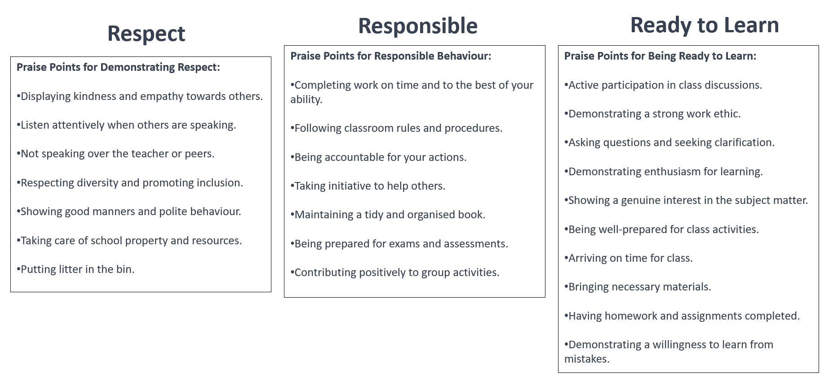

Appendix 2 – In-Class Behaviour
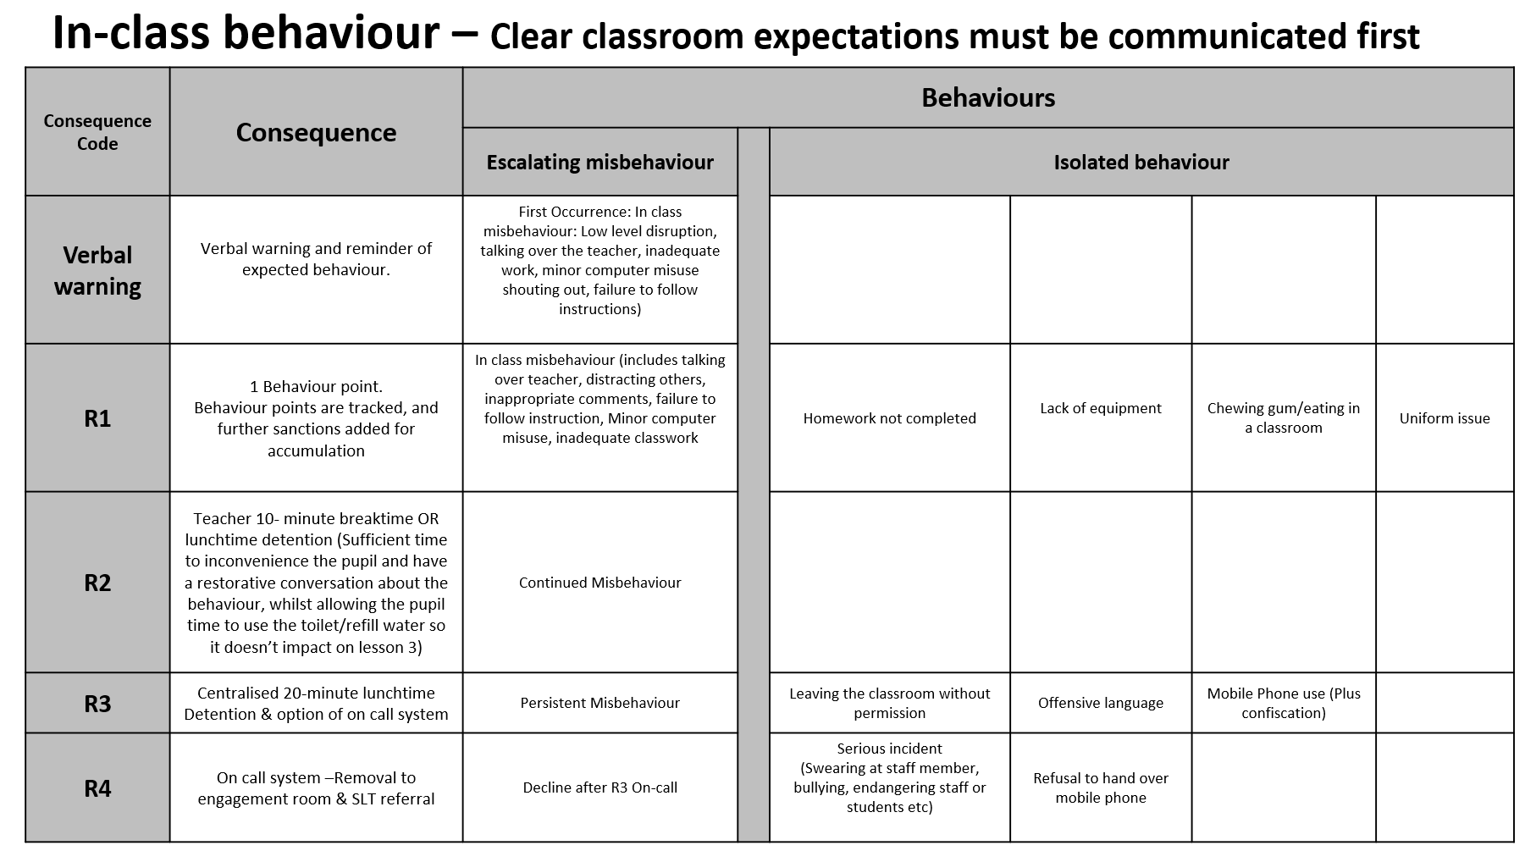

Appendix 3 – Out of Class Behaviour
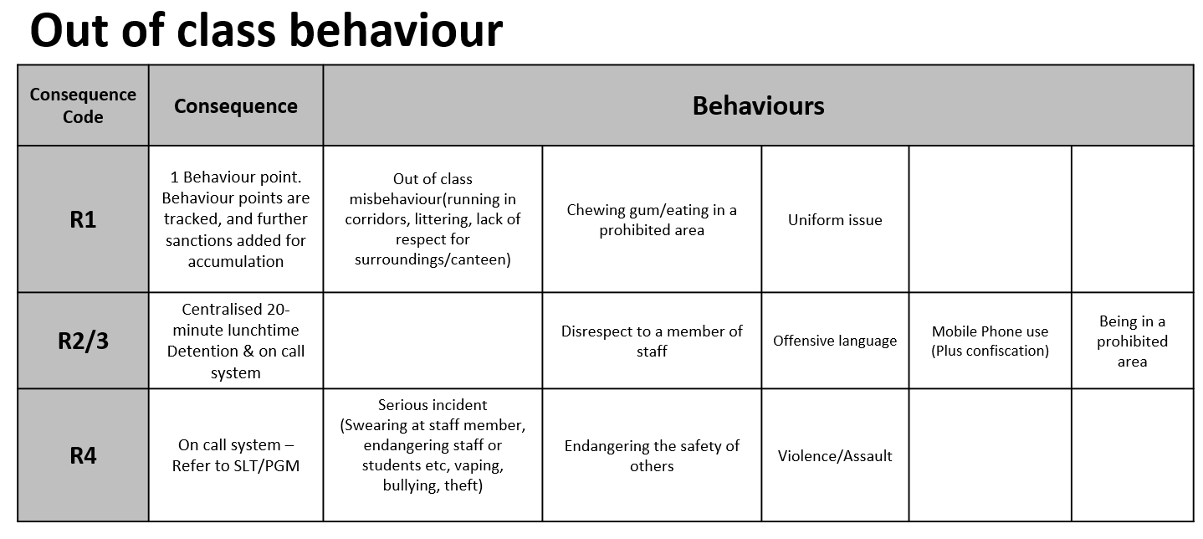

Appendix 4 – On-call process
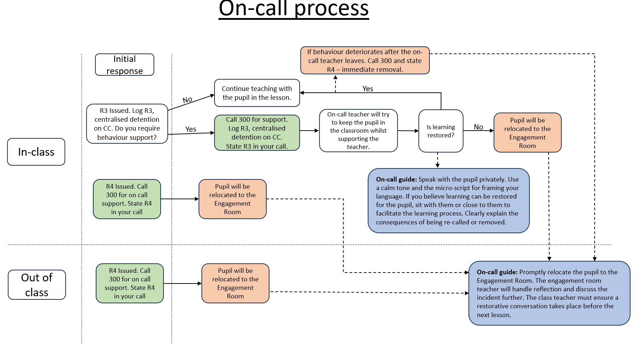

Appendix 5 – Accumulating Behaviour Points

