- To develop your reading skills
- To deepen your understanding of texts
- To plan and write a narrative, using the stimulus extracts
Rebellion and survival
KS4 unit of work

BOOKLET’S AIMS:

Anthony Jones, Jane Shilling, Emma Wright
ACTIVITY 1: What does it mean to rebel?

ACTIVITY 2: Rebellion in fiction

ACTIVITY 3: Rebellion today

Activity 4: Rebellion and survival

Activity 5: Survival

Activity 6: Your story of rebellion

ACTIVITY 1: What does it mean to rebel?
Learning Objectives:
- To develop skills in location and inference and learn how to answer a synthesis question.
Task 1: What does the word rebel suggest to you? Think about times you may have heard the word – maybe in history or in the news. Write down your thoughts and ideas below:
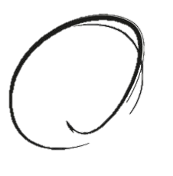

rebel

The word ‘rebel’ comes from the Latin rebellis which meant originally to make war again. ‘Re’ means again and ‘bellis’ means I wage war. Many words in English start with re- such as review – to look at something again. Can you think of any others?
We use the word rebel as a verb and a noun:
She rebelled against the school uniform policy. [verb]
He was a known rebel and called for a change in government. [noun]
To describe someone as a rebel we add the suffix –ious and call them rebellious.
We use the word rebellion as a noun to describe the act of rebelling.
The meaning of ‘to rebel’ is to oppose someone or thing that is in authority or control:
The people rebelled against the new harsh government.
We use it to mean being disobedient and disliking rules, which is shown by behaving differently to most people in society:
David rebelled against his parents’ plans for him and left school at 16.
We also use it to mean reacting against a feeling, plan or action:
Her stomach rebelled against the idea of eating any more food.

Task 2
In the sentence below, is ‘rebel’ being used as a verb or noun? | Your answer
Jamie disliked the new rules about PE. He was so angry he disobeyed the rules and became known as a rebel.
Children often rebel against being forced to eat certain foods.
She rebelled against every rule her parents set.
The government tried to set up talks with the rebels.
As a teenager, it is natural to want to rebel – it’s part of growing up.
Rebels marched through the town yesterday, protesting about the ban on social media.

Task 3: synthesising information from two texts

Top Tips for Synthesise Questions
- When we synthesise we find information on a key topic from two, or more, texts.
- Read each text and locate the details that answer the question in each one – you could highlight them.
- Use subheadings to organise your answer into 2 paragraphs. Text A says and write up your 5 or 6 points from that text….. Text B says: and write up your 5 or 6 points from that text.
- Keep the focus on what the question is asking.
- You don’t need to use PEE. Make a short point and back it up with the quotation.
- 10 marks = 10 quotations.
- Use the question words throughout your answer eg teenagers rebel because ...
- You don’t need to compare the texts.
- Don’t waste time analysing words.

Read the two texts below and answer the question:
Synthesise why, according to Texts A and B, teenagers rebel.

Text A
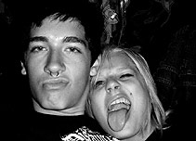
Teenage emotions: Teenage rebellion
There are very few perfectly behaved teenagers. Many of them take part in some kind of dangerous, unhealthy or anti-social pursuit.
Activities like drinking, smoking, watching adult videos or having under-age sex are common in teenagers. Some even get up to more serious things like stealing or taking drugs.
It's alarming for parents, but the good news is - it doesn't last.
Statistics for boys show that teenage criminal behaviour tends to begin around the age of 13, peak at 17 and then disappear almost completely in early adulthood.
Independent minds
Rebelling in teenagers is often symbolic. They want to look grown up and impress their friends. If parents disapprove, it often makes teenage behaviour worse and arguments are common. They defy adult restrictions deliberately as a way of asserting their independence.
Teenagers have reason to be confused because they are part of the adult world in a biological sense, but are still not permitted to do many of the things that adults can.
Taking risks
Experimentation is a way for teenagers to learn to take responsibility for their own actions. It is a step towards becoming more mature and adult-like and in learning to make choices and decisions.
Risky behaviour is seen by adults as being a 'bad' thing, but for the teenagers there are many rewards. By pushing boundaries they are developing their identity as well as showing off in front of friends. There are suggestions from recent research that some bad teenage behaviour could be a sign of a healthy personality.
Growing brains
There is one other reason why teenagers might rebel. Scientists have used advanced scanning methods to study the changes that occur in the adolescent brain. Much to their surprise, they have discovered that the brain continues to develop and grow well into the teenage years.
This might explain a teenager's risk-taking behaviour. It has emerged that the emotional region of the brain develops to maturity ahead of the part of the brain that controls rational thought. In other words, teenagers have well-developed emotions and feelings but have still not acquired the ability to think things through. When they act impulsively, and do the kind of dangerous things an adult would avoid, their brain's late development might be to blame.
Teenagers' well developed emotions could also be the cause of another characteristic they are often accused of – moodiness.

Text B

Why kids rebel:
What kids believe about the legitimacy of adult authority
Rebel without a cause? Not really. Studies suggest that kids recognise our authority in certain matters. But they resist when they perceive us as trying to control their personal lives.
Nobody is born programmed to defer to authority. As adolescence approaches, kids are likely to question adult authority and rebel. Yet they aren’t anarchists; nor are they scheming to run the world. On the contrary, even teenagers are ready to be cooperative.
There is a catch, however, and it’s a big one. Kids recognise limits to our authority. Like us, they regard certain matters as personal. And when they think that an authority figure is overreaching – meddling in their personal affairs – kids are more likely to resist.
How they resist depends. They might protest and argue, hoping to persuade us to change policy. Or they might avoid direct conflict, and disobey us on the sly. But either way, they judge our authority to be illegitimate. We simply don’t have the right to interfere.
It’s interesting to think about how we respond to authority. No matter how we feel generally about authority, how we respond depends on the individual situation. If the authority is trying to enforce a rule that corresponds with our own moral principles, or seems reasonable, we’re likely to comply. The zookeeper tells you not to rattle the door of the lion’s cage, so you don’t. But none of us give authority figures unlimited power. If your boss tried to tell when to get up on your day off – not an area he has authority over – you’d resent and probably ignore. Authority has limits.
As it turns out, kids feel the same way, especially teenagers. Whilst they agree that it is acceptable for adults to impose sensible rules about safety, in other areas they are more questioning of authority. They are most united in their opposition toward commands which contradict their own views: 95% of them said it was right for the protagonist to disobey such an order from a parent or teacher. Teenagers were also resistant to directives about a child’s hobbies and friendships. 90% saw this as an illegitimate overreach of authority.
Similarly rules designed to regulate teenagers’ personal choices are often fought against. When parents try to control adolescents’ lives, teens are more likely to perceive that authority as illegitimate. When a parent tries to control the friends that a teenager wants to spend time with, the online media they use, how they spend their money, or how late they sleep on weekends, they are far more likely to rebel. Indeed, research has found that the more rules in a family, the more likely teenagers are to rebel.

ACTIVITY 2: Rebellion in fiction

Learning Objectives:
- To develop skills in analysing mood and atmosphere
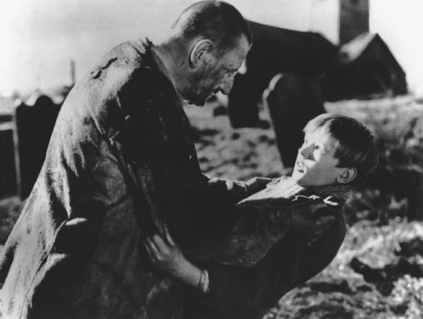
Task 1
Think of a film or television programme that you have seen that you found tense or exciting. How did it make you feel that mood of tension or excitement? Eg was it the use of music or the setting itself?
If you can you may want to watch the opening of the film ‘Great Expectations’ directed by David Lean. It’s an old film but the opening builds tension very well! Search “opening Great Expectations David Lean.” [ https://www.youtube.com/watch?v=eXyo68s-f1E].
Writers are a little like film directors – they use ‘tricks’ or techniques to create mood and atmosphere in stories.

Description of the setting

Use of time- eg. midnight, dusk
Characters’ actions

Task 1: Read the following texts: how do they maintain our interest as a reader? appeal to the audience/reader osand gain our interest?
Use of direct speech
Use of weather: heat, storms
How does a writer create mood and atmosphere?
Use of imagery: metaphor, simile, personification
Main character’s thought and feelings

Word choice
Sentence type and length

Task 2
Read the text below and then answer the questions:
In this extract from ‘The Hunger Games, the main character, Katniss, carries out an attack on the Careers – those who are trained to fight in the Hunger Games, which are her enemy.

There’s no sense in putting it off. I take a deep breath, grip the knife handle and bear down as hard as I can on the branch. Back, forth, back, forth! The tracker jackers* begin to buzz and I hear them coming out. Back, forth, back, forth! A stabbing pain shoots through my knee and I know one has found me and the others will be honing in. Back, forth, back, forth. And just as the knife cuts through, I shove the end of the branch as far away from me as I can. It crashes down through the lower branches, snagging temporarily on a few but then twisting free until it smashes with a thud on the ground. The nest bursts open like an egg, and a furious swarm of tracker jackers takes to the air. I feel a second sting on the cheek, a third on my neck, and their venom almost immediately makes me woozy. I cling to the tree with one arm while I rip the barbed stingers out of my flesh. Fortunately, only these three tracker jackers had identified me before the nest went down. The rest of the insects have targeted their enemies on the ground.

It’s mayhem. The Careers* have woken to a full-scale tracker jacker attack. Peeta and a few others have the sense to drop everything and bolt. I can hear cries of “To the lake! To the lake!” and know they hope to evade the wasps by taking to the water. It must be close if they think they can outdistance the furious insects. Glimmer and another girl, the one from District 4, are not so lucky. They receive multiple stings before they’re even out of my view. Glimmer appears to go completely mad, shrieking and trying to bat the wasps off with her bow, which is pointless. She calls to the others for help but, of course, no one returns. The girl from District 4 staggers out of sight, although I wouldn’t bet on her making it to the lake. I watch Glimmer fall, twitch hysterically around on the ground for a few minutes, and then go still.

*Tracker jackers are genetically engineered wasps, which have a gold body, leave stings that swell up as big as an orange, chase their victims, and possess venom that causes hallucinations and is so strong that only a few stings can kill a person.
*Careers are tributes (those who fight in the games) who train specifically throughout their life to compete in the Hunger Games. They attend a special combat academy to be trained by victors until they're 18, when they volunteer. They are usually wealthier, and therefore stronger and healthier.

- Which one of the following statements is NOT true? Tick (✓) that box.
One of the tracker jackers stings Katniss on her knee
Katniss cuts through the tree branch where the nest is so it falls down
The tracker jackers sting Katniss repeatedly all over her body
The Careers run towards the lake to try to avoid the tracker jackers

- Explain what is meant by the phrase “they hope to evade the wasps by taking to the water” in your own words.

-------------------------------------------------------------------------------------------------------------------------------------

-------------------------------------------------------------------------------------------------------------------------

- How does the writer create mood and atmosphere in the extract?
_______________________________________________________________________________________________________________________________________________________________________________________________________________________________________________________________________________________________________________________________________________________________________________________________________________________________________________________________________________________________________________________________________________________________________________________________________________________________________________________________________________________________________________________________________________________________________________________________________________________________________________________________________________________________________________________________
_______________________________________________________________________________________________________________________________________________________________________________________________________________________________________________________________________________________________________________________________________________________________________________________________________________________________________________________________________________________________________________________________________________________________________________________________________________________________________________________________________________________________________________________________________________________________________________________________________________________________________________________________________________________________________________________________
________________________________________________________________________________________________________________________________________________________________________________________________________________________________________________________________________________________________________________________________________________________________________________________________________
________________________________________________________
_______________________________________________________________________________________________________________________________________________________________________________________________________________________________________________________________________________________________________________________________________________________________________________________________________________________________________________________________________________________________________________________________________________________________________________________________________________________________________________________________________________________________________________________________________________________________________________________________________________________________________________________________________________________________________________________________

ACTIVITY 3: Rebellion today

Learning Objective:
- To improve your reading skills of retrieval.
Task 1:
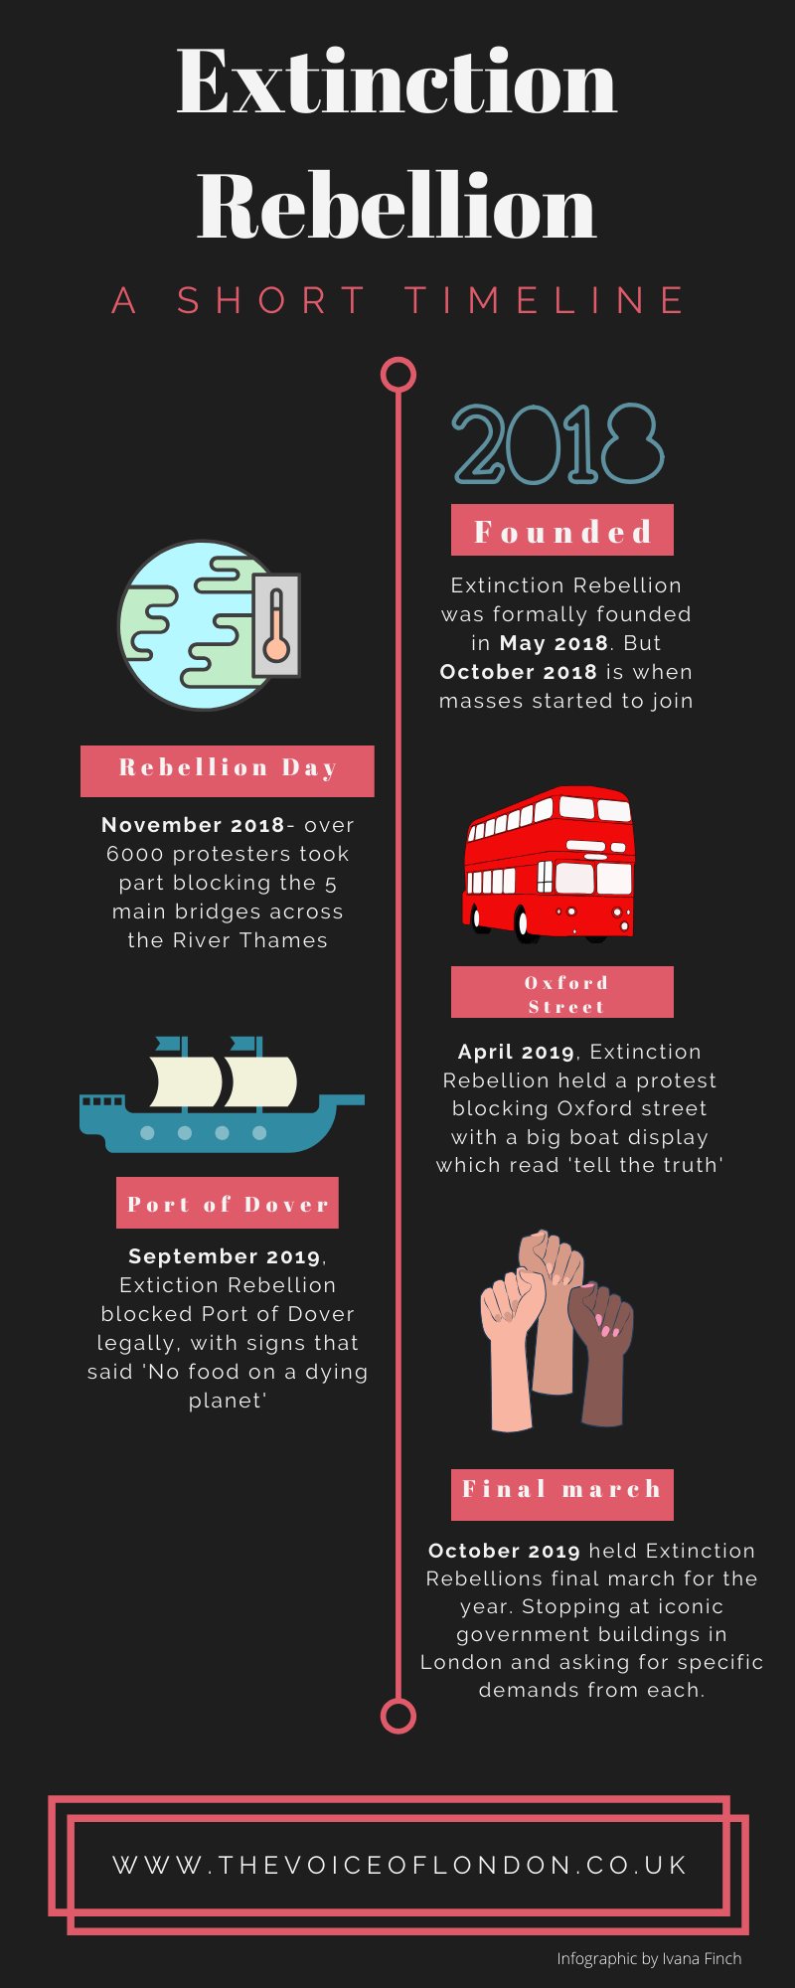
Using the information in the infographic below answer the questions

A1. When did people start to join Extinction Rebellion?
………………………………………………………………………………………….
A2. What event was organised in September 2019?
………………………………………………………………………………………….
A3. Which of the following statements best explains the word ‘iconic’?
Tick (✓) the correct box. [1 mark]

A word used to describe a place that people visit when travelling

A word used for something that looks spectacular

A word used to describe something that very popular and important

A word used for things of religious importance

Task 2
The following text is an article from BBC News. Read the article and answer the questions:

What is Extinction Rebellion and what does it want?
Extinction Rebellion (XR for short) wants governments to declare a "climate and ecological emergency" and take immediate action to tackle climate change. It describes itself as an international "non-violent civil disobedience activist movement".
Extinction Rebellion was launched in 2018 and organisers say it now has groups willing to take action in dozens of countries. The group uses an hourglass inside a circle as its logo, to represent time running out for many species.
Extinction Rebellion Facts
2025 year when the group aims for zero carbon emissions
298,000 followers on Facebook
1,130 people arrested over April's London protests
2018 year the group was founded

In the UK, Extinction Rebellion has 3 main demands:

The government must declare a climate "emergency"
The UK must legally commit to reducing carbon emissions to net zero by 2025
A citizens' assembly must be formed to "oversee the changes"
Reducing CO2 emissions to almost zero in six years' time would be extremely ambitious. Severe restrictions on flying would be needed. Diets would have to change, by drastically cutting back on meat and dairy. And there would have to be a massive increase in renewable energy, along with many other radical changes.
But those involved with Extinction Rebellion say the future of the planet depends on it. "We have left it so late that we have to step up in a semi-miraculous way to deal with this situation," said co-founder Gail Bradbrook.
What are its tactics?
In April 2019, Extinction Rebellion held a large demonstration in London. Over the course of 11 days, some of the city's busiest routes were brought to a standstill.
The action resulted in more than 1,100 arrests - most on suspicion of not following police instructions to move. Some activists glued themselves to trains and to the entrance of the London Stock Exchange. Some marched on Heathrow Airport and others chained themselves up.
It is not difficult to find people who object to Extinction Rebellion's tactics - from delayed drivers on Twitter to newspaper columnists. Its supporters have been criticised as “environmental fanatics” who plan to ruin thousands of holidays and risk alienating thousands of potential supporters. April’s London protests cost the police an extra £7.5m, according to Met Police Commissioner Cressida Dick.

1. List 3 things that would need to happen to meet Extinction Rebellion’s demand for zero carbon emissions by 2025.
- -------------------------------------------------------------------------------------------------------

- -------------------------------------------------------------------------------------------------------

- -------------------------------------------------------------------------------------------------------
Top Tip:
Look at where the word is used in the text and how it relates to the article
2. Explain what is meant by “environmental fanatics”.
--------------------------------------------------------------------------------------------------------------
--------------------------------------------------------------------------------------------------------------
--------------------------------------------------------------------------------------------------------------
--------------------------------------------------------------------------------------------------------------

3. Look at the section entitled “What are its tactics?”
List 3 different things members of Extinction Rebellion did in April 2019 as part of its protest in London.

……………………………………………………………………………………………….
……………………………………………………………………………………………….
…………………………………………………………………………………………………
4. Extinction Rebellion describe themselves as a “civil disobedience activist movement”.
Which of the following definitions best fits the word ‘activist’ in this context?
Tick (√) the correct box.

A movement that is physically active and believes in exercise

A movement that believes strongly in political change and organises events to
try to make this happen

A movement that has a specific purpose and aim and promotes itself widely

A movement that has strict rules and only allows certain people to join it

5. Explain what you learn about Extinction Rebellion from this article. [5]
_________________________________________________________________________________________________________________________________________________________________________________________________________________________________________________________________________________________________________________________________________________________________________________________________________________________________________________________________________________________________________________________________________________________________________________________________________________________________________________________________________________________________________________________________________________________________________________________________________________________________________________________________________
Activity 4: Rebellion and survival

Learning Objective:
- To develop your skills of inference in reading
When we read a story we use skills of inference – working out, for ourselves, what is going on “between the lines” or the sub text as some people call it.
We use this skill in our daily lives all the time, for example when someone is angry they might not say they are feeling angry, but may shout or slam or door. We work out that they’re angry, and that is the skill of inference.

Task 1:
Read the extract below and then answer the questions that follow:

In this extract from ‘The Hunger Games’ Katniss has to take part in a contest, against other tributes from different regions, in a fight for survival.
Sixty seconds. That’s how long we’re required to stand on our metal circles before the sound of a gong releases us. Step off before the minute is up, and land mines blow your legs off. Sixty seconds to take in the ring of tributes all equidistant from the Cornucopia, a giant golden horn shaped like a cone with a curved tail, the mouth of which is at least twenty feet high, spilling over with the things that will give us life here in the arena. Food, containers of water, weapons, medicine, garments, fire starters. Strewn around the Cornucopia are other supplies, their value decreasing the farther they are from the horn. Only a few steps from my feet lies a three-foot square of plastic. But there in the mouth, I can see a tent pack that would protect from almost any sort of weather. If I had the guts to go in and fight for it against the other twenty-three tributes. Which I have been instructed not to do.
We’re on a flat, open stretch of ground. A plain of hard-packed dirt. Behind the tributes across from me, I can see nothing, indicating either a steep downward slope or even a cliff. To my right lies a lake. To my left and back, sparse piney woods. This is where Haymitch would want me to go. Immediately. I hear his instructions in my head. “Just clear out, put as much distance as you can between yourselves and the others, and find a source of water.”
But it’s tempting, so tempting, when I see the bounty waiting there before me. And I know that if I don’t get it, someone else will. Something catches my eye. There, resting on a mound of blanket rolls, is a silver sheath of arrows and a bow, already strung, just waiting to be engaged. That’s mine, I think. It’s meant for me.
I’m fast. I can sprint faster than any of the girls in our school, although a couple can beat me in distance races. But this forty-yard length, this is what I am built for. I know I can get it, I know I can reach it first, but then the question is how quickly can I get out of there? By the time I’ve scrambled up the packs and grabbed the weapons, others will have reached the horn, and one or two I might be able to pick off, but say there’s a dozen, at that close range, they could take me down with the spears and the clubs. Or their own powerful fists. Still, I won’t be the only target. I’m betting many of the other tributes would pass up a smaller girl, even one who scored an eleven in training, to take out their more fierce adversaries.
Haymitch has never seen me run. Maybe if he had he’d tell me to go for it. Get the weapon. Since that’s the very weapon that might be my salvation. And I only see one bow in that whole pile. I know the minute must be almost up and will have to decide what my strategy will be and I find myself positioning my feet to run, not away into the surrounding forests but toward the pile, toward the bow. When suddenly I notice Peeta, he’s about five tributes to my right, quite a fair distance, still I can tell he’s looking at me and I think he might be shaking his head. But the sun’s in my eyes, and while I’m puzzling over it the gong rings out.
And I’ve missed it! I’ve missed my chance! Because those extra couple of seconds I’ve lost by not being ready are enough to change my mind about going in. My feet shuffle for a moment, confused at the direction my brain wants to take and then I lunge forward, scoop up the sheet of plastic and a loaf of bread. The pickings are so small and I’m so angry with Peeta for distracting me that I sprint in twenty yards to retrieve a bright orange backpack that could hold anything because I can’t stand leaving with virtually nothing.
A boy, I think from District 9, reaches the pack at the same time I do and for a brief time we grapple for it and then he coughs, splattering my face with blood. I stagger back, repulsed by the warm, sticky spray. Then the boy slips to the ground. That’s when I see the knife in his back. Already other tributes have reached the Cornucopia and are spreading out to attack. Yes, the girl from District 2, ten yards away, running toward me, one hand clutching a half-dozen knives. I’ve seen her throw in training. She never misses. And I’m her next target.
All the general fear I’ve been feeling condenses into an immediate fear of this girl, this predator who might kill me in seconds. Adrenaline shoots through me and I sling the pack over one shoulder and run full-speed for the woods. I can hear the blade whistling toward me and reflexively hike the pack up to protect my head. The blade lodges in the pack. Both straps on my shoulders now, I make for the trees. Somehow I know the girl will not pursue me. That she’ll be drawn back into the Cornucopia before all the good stuff is gone. A grin crosses my face. Thanks for the knife, I think.
Excerpt from The Hunger Games © 2008 by Suzanne Collins

1. Which of the following statements best explains the word ‘equidistant’?
Tick (✓) the correct box. [1 mark]

The distance from the middle to the outside of a space

A space for horses

The time it takes to get from one place to another

When things are located at an equal distance

2. Explain what is meant by the word “bounty” in the third paragraph.
---------------------------------------------------------------------------------------------------------
---------------------------------------------------------------------------------------------------------
---------------------------------------------------------------------------------------------------------
---------------------------------------------------------------------------------------------------------
3. List two things you learn about Katniss in the fourth paragraph.
i………………………………………………………………………………………………………………………………………………………
ii.……………………………………………………………………………………………………………………………………………………

4. What impressions do you get of Katniss in this extract?
To answer this question you will need to use skills of inference – to work out what the text is suggesting about her.
To start with you may find it helpful to complete the grid below, which shows how you can use PEE to structure your answer. It includes a few quotations you may wish to use in your answer but does not cover all the points you can make.
Point | Evidence | Explanation
I have the impression Katniss is alert and intelligent. | As she stand waiting, she describes “Only a few steps from my feet” there is “a three-foot square of plastic” but there is a “tent pack” in the mouth of the horn. | This suggests that Katniss can think quickly and evaluate the options she has, and what she should do. She realises that the plastic, although near her, would not be as useful as the tent, but this would be much harder to get.
Also, when she ………I have the impression she is | She states where Haymitch would want her to go. “I hear his instructions in my head.” | This conveys that Katniss is ….
 | She sees the bow and arrows and thinks “That’s mine”. | This suggests …….
 | She knows she is fast as this “forty yard distance” is what she’s “built for” and that “I can reach it”
However, I also have the impression that | She also questions in her mind “how quickly can I get out of there?”
Top Tip:
Keep your focus on your impression of Katniss. Use the question wording to start your points.
Write up your answer below:
_________________________________________________________________________________________________________________________________________________________________________________________________________________________________________________________________________________________________________________________________________________________________________________________________________________________________________________________________________________________________________________________________________________________________________________________________________________________________________________________________________________________________________________________________________________________________________________________________________________________________________________________
______________________________________________________________________________________________________________
_______________________________________________________
_______________________________________________________
_______________________________________________________

________________________________________________________________________________________________________________________________________________________________________________________________________________________________________________________________________________________________________________________________________________________________________________________________________________________________________________________________________________________________________________________________________________________________________________________________________________________________________________________________________________________________________________________________________________________________________________________________________________________________________________________________________________________________________________
_______________________________________________________
_______________________________________________________
______________________________________________________________________________________________________________
_______________________________________________________
_______________________________________________________
Activity 5: Survival

Learning Objectives:
- To develop your skills in answering ‘how does the writer’ questions
Task 1:
The image below shows a man climbing on an ice face. How would you feel if you were this climber and felt yourself falling? Write down all the words around the image to describe it.
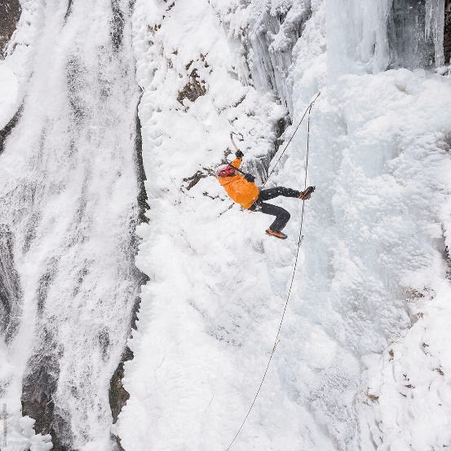
freezing

precarious

How questions, such as, how does the writer … ask you to think about the content of the story and how the writer has communicated that to us. You need to think about what happens in a story and what words the writer has used to describe the events and the character.

Top Tips for How Questions
- How questions ask us to think about how the writer has structured the text and comment on the content of the text and word choice.
- Track through the text with a clear focus on what the question is asking.
- Highlight and annotate key words/phrases.
- Use PEEL point, evidence, explain, link back to the question.
- 5 marks = 5 quotations
- Focus on the effect of words.

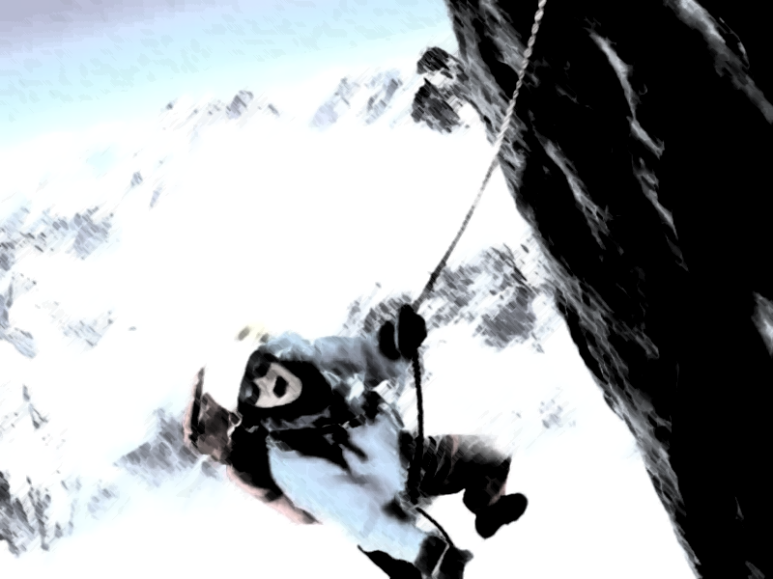
Read the extract below about a man’s fight to survive
I hit the slope at the base of the cliff before I saw it coming. I was facing into the slope and both knees locked as I struck it. I felt a shattering blow in my knee – felt bones splitting – and I screamed. The impact catapulted me over backwards and down the slope of the East Face. I slid, head first, on my back. The rushing speed of it confused me… I thought of the drop below but felt nothing. Since we were roped together, Simon would be ripped off the mountain. He couldn’t hold me. I screamed again as I jerked to a sudden violent stop.

Everything was still, silent. My thoughts raced madly. Then pain flooded down my thigh – a fierce burning fire coming down the inside of my thigh, seeming to ball in my groin, building and building until I cried out at it, and breathing came in ragged gasps. My leg! My leg!
I hung, head down, on my back, left leg tangled in the rope above me and my right leg hanging slackly to one side. I lifted my head from the snow and stared, up across my chest, at a grotesque distortion in the right knee, twisting the leg into a strange zig-zag. I didn’t connect it with the pain which burnt in my groin. That had nothing to do with my knee. I kicked my left leg free of the rope and swung round until I was hanging against the snow on my chest, feet down. The pain eased. I kicked my left foot into the slope and stood up.
A wave of nausea surged over me. I pressed my face into the snow, and the sharp cold seemed to calm me. Something terrible, something dark with dread occurred to me, and as I thought about it, I felt the dark thought break into panic: “I’ve broken my leg, that’s it. I’m dead. Everyone said it ... if there’s just two of you a broken ankle could turn into a death sentence ... if it’s broken if ... it doesn’t hurt so much, maybe I’ve just ripped something.”

Touching the Void

1. Find one word which describes how Joe feels when he falls off the cliff in the first paragraph.

--------------------------------------------------------------------------------------------------------------------------
2. Find two words which describe the pain he felt, in the second paragraph.

--------------------------------------------------------------------------------------------------------------------------
3. Explain what he means when he says “I felt the dark thought break into panic”.

--------------------------------------------------------------------------------------------------------------------------------------
4. How does the writer convey Joe’s feelings after the accident? [5 marks]
Remember to think about not only what he is feeling but how the writer conveys/shows those feelings. You need to comment on techniques and word choice.
The table below may help you structure your answer.
_____________________________________________________________________________________________________________________________________________________________________________________________________________________________________________________________________________________________________________________________________________________________________________________________________________________________________________________________________________________________________________________________________________________________________________________________________________________________________________________________________________________________________________________________________________________________________________________________________________________
Point: Use the question wording. Focus on his feeling. | At the start, when Joe hits the slope and his knees lock, which is unexpected, he feels shock and enormous pain.
Evidence: find evidence in the text that backs up your point. Avoid long quotations. | He states that he “felt a shattering blow in my knee – felt bones splitting – and I screamed.”
Analyse the Effect: Analyse – spell out – how the writer conveys Joe’s feelings – talk about word choice, technique and sentence types.  Link back to the question | The use of the words “shattering” and “splitting” suggest the horror of the accident as they suggest something violent and sudden and the short phrase “I screamed” bluntly conveys his feelings of agony and fear.
Activity 6:
________________________________________________________________________________________________________________________________________________________________________________________________________________________________________________________________________________________________________________________________________________________________________________________________________________________________________________________________________________________________________________________________________________________________________________________________________________________________________________________________________________________________________________________________________________________________________________________________________________________________________________________________________________________________________________
_______________________________________________________
_______________________________________________________
______________________________________________________________________________________________________________
_______________________________________________________
_______________________________________________________
Activity 6: Your story of rebellion

Learning objective:
- To develop skills in personal writing
Task 1:
Read the short story below.
Think about why it is engaging. In the space provided under the story write a 5 point success criteria for an engaging personal story.
A sense of mystery
Character’s thoughts
In this story, Professor Millward is alone in London, after England becomes permanently snowbound…
The thick furs thudded softly to the ground as Professor Millward sat upright on the narrow bed. He had heard that roar again. The freezing air that rasped against his lungs seemed to echo with the sound that had come crashing out of the night. All was quiet again. The world was utterly still. Professor Millward shuffled out of bed and made his way to the nearest window, pausing now and then to rest his hand lovingly on the books he had guarded all these years. He shielded his eyes from the brilliant moonlight and peered out into the night. The sky was cloudless: the sound had not been thunder, whatever it might have been. It had come from the north, and even as he waited it came again. Distance and the bulk of the hills that lay beyond London had softened it. It was like no natural sound that he had ever heard, and for a moment he dared to hope again. Only Man, he was sure, could have made such a sound. Perhaps the dream that had kept him here for more than twenty years would soon be a dream no longer. Perhaps men were returning to England again after the disaster that had seen the evacuation that ended with helicopters climbing heavily out of Hyde Park in the ceaselessly falling snow. Even then, when the silence had closed around him, he could not bring himself to believe that England had been abandoned forever.
He had been waiting ever since, watching as the dome of St Paul’s had collapsed beneath the weight of snow, leaving the University Building, where he lived, standing alone. He left the building only through sheer necessity. Over the past twenty years he had collected everything he needed from the shops in the area, for in the final exodus vast supplies of stock had been left behind. Yet this morning he needed to leave.
The sun was blazing from a cloudless sky as he shouldered his rucksack and unlocked the massive gates. Even ten years ago, packs of starving dogs had hunted in this area, and though he had seen none for years, he was still cautious and always carried a revolver when he went into the open. The sunlight was so brilliant that the reflected glare hurt his eyes; but it was almost wholly lacking in heat. The latest snowdrifts had packed hard and Professor Millward had little difficulty making the journey to Oxford Street. He kept away from the houses with their dangerous burdens of snow and their dagger-like icicles and went north until he came to the shop he was seeking.
Short sentence - tension
Use of metaphor
Verbs to show his fear
Detailed description
The words above the shattered windows were still bright: ‘Jenkins and Sons. Electrical.’ Some snow had drifted through a broken section of roofing, but the little upstairs room had not altered since his last visit. The radio still stood on the table, and the empty tins on the floor reminded him of the lonely hours he had spent here. Slowly, with infinite patience, Professor Millward began to traverse the radio bands. As he listened, the faint hope that he had dared to cherish began to fade. The radio was as silent as the city.
As he began the journey home, the silence was broken by a distant rumble of thunder and little avalanches of snow went swishing into the wide street. Professor Millward stood motionless, considering, analysing. Perhaps it was an atomic bomb, burning and blasting away the snow. His hopes revived and his disappointments of the night began to fade. That momentary pause almost cost him his life. Out of a side street something huge and white moved suddenly into his field of vision. For a moment his mind refused to accept the reality of what he saw. Then the paralysis left him and he fumbled desperately for his futile revolver. Padding towards him, swinging its head from side to side, was a huge polar bear. He dropped his belongings and ran, floundering over the snow towards the nearest building. The entrance to an Underground station was only a few feet away. The temptation to look back was intolerable, for he could hear nothing to tell him how near his pursuer was. For one frightful moment the steel gates resisted his numbed fingers. Then they yielded reluctantly and he forced his way through a narrow gap. The monstrous shape reared in baffled fury against the gates but the metal did not yield. Then the bear dropped to the ground, grunted softly and padded away.
A very shaken Professor Millward reached the University three hours later, after moving in short bounds from one refuge to the next. By the end of the week he knew that the animals of the North were on the move. He saw a reindeer being pursued by a pack of silent wolves, and sometimes in the night there were sounds of deadly conflict. Something was driving them south. He hoped it was Man, coming back to England and he began to dream of rescue. Several times a day that strange roar would thunder over the city. It was coming nearer.
Every morning he would climb to the top of the building and scan the horizon, but all he ever saw was the stubborn snow above Hampstead. His ordeal ended one morning as he raised his binoculars to the northern sky. In that moment, Professor Millward knew the truth. Overnight, the enemy he had forgotten had conquered the last defences and was preparing for the final onslaught. As he saw the deadly glitter along the crest of the doomed hills, Professor Millward understood at last the sound he had heard advancing for so many months. Out of the North, their ancient home, returning in triumph to the lands they had once possessed, the ice glaciers were coming – to kill anything that was still alive.

My success criteria for an engaging narrative:

- -----------------------------------------------------------------------------------------------------------------

- -----------------------------------------------------------------------------------------------------------------

- -----------------------------------------------------------------------------------------------------------------

- -----------------------------------------------------------------------------------------------------------------

- -----------------------------------------------------------------------------------------------------------------
Task 2: Write an account of a time you were rebellious OR
Describe an occasion when you survived something.

Plan your story below: you may find it helpful to use the grid below:
H | The Hook  Create a paragraph that will grab the reader straight away. Perhaps start in the action? At the end? Hint at future events?
S | Setting  Create a paragraph, showing not telling, where your story is set.
P | Person/ Other Person  Describe the main character or other person giving key details about who they are, perhaps using dialogue.
A | Action  Describe an event that fires your story into excitement and interest.
C | Change  Describe how the main character or other person has changed and grown since the beginning of the story
E | Ending with points to the future  Conclude your story with a fitting ending that shows development in the future

Top Tips for narrative
Is the main character interesting? Why?
Where is it set?
How does it begin?
What conflict or problem does the character face?
How is this resolved?
Does the end point to the future?

_____________________________________________________________________________________________________________________________________________________________________________________________________________________________________________________________________________________________________________________________________________________________________________________________________________________________________________________________________________________________________________________________________________________________________________________________________________________________________________________________________________________________________________________________________________________________________________________________________________________
________________________________________________________________________________________________________________________________________________________________________________________________________________________________________________________________________________________________________________________________________________________________________________________________________________________________________________________________________________________________________________________________________________________________________________________________________________________________________________________________________________________________________________________________________________________________________________________________________________________________________________________________________________________________________________
_______________________________________________________
_______________________________________________________
______________________________________________________________________________________________________________
_______________________________________________________
_______________________________________________________
________________________________________________________________________________________________________________________________________________________________________________________________________________________________________________________________________________________________________________________________________________________________________________________________________________________________________________________________________________________________________________________________________________________________________________________________________________________________________________________________________________________________________________________________________________________________________________________________________________________________________________________________________________________________________________
_______________________________________________________
_______________________________________________________
______________________________________________________________________________________________________________
_______________________________________________________
_______________________________________________________
ANSWERS
ACTIVITY 1.
Task 2:
In the sentence below, is ‘rebel’ being used as a verb or noun? | Your answer
Jamie disliked the new rules about PE. He was so angry he disobeyed the rules and became known as a rebel. | noun
Children often rebel against being forced to eat certain foods. | verb
She rebelled against every rule her parents set. | verb
The government tried to set up talks with the rebels. | noun
As a teenager, it is natural to want to rebel – it’s part of growing up. | verb
Rebels marched through the town yesterday, protesting about the ban on social media. | noun

Task 3:
Synthesise why, according to Texts A and B, teenagers rebel
Text A:
- They want to look grown up and impress their friends.
- If parents disapprove, it often makes teenage behaviour worse.
- They defy adult restrictions deliberately as a way of asserting their independence.
- Experimentation is a way for teenagers to learn to take responsibility for their own actions.
- It helps teenagers become more mature and learn to make choices and decision themselves.
- By pushing boundaries teenagers are developing their identity
- Some bad teenage behaviour could be a sign of a healthy personality.
- Rebellion can be a sign of changes that occur in the adolescent brain. The emotional side develops before the rational side so their brain's late development might be to blame.
Text B:
- Teenagers rebel when they perceive adults as trying to control their personal lives.
- It is natural for teenagers to question authority as we aren’t born programmed to defer to authority.
- Teenagers recognise limits to authority and will resist if they think someone is overreaching.
- Teenagers will question authority in certain areas such as commands that contradict their own views.
- Teenagers will rebel against commands concerning hobbies and friendships as it is an illegitimate overreach of authority.
- Rules designed to regulate teenagers’ personal choices cause rebellion as teenagers see that authority as illegitimate.
- Teenagers are more likely to rebel when a parent tries to control the friends that a teenager wants to spend time with, the online media they use, how they spend their money, or how late they sleep on weekends.
- Teenagers rebel if there are too many rules in a family.

ACTIVITY 2
Task 2:
1. The tracker jackers sting Katniss repeatedly all over her body
2. The Careers run away from the wasps to try to escape from them and run towards the lake. You need to explain the word evade here, which means to avoid, get away from or escape.
3. You could have explored some of the following points:
- The answer should state what mood is being created eg tension, suspense and fear.
- Description of Katniss sawing off the tree “back,forth,back forth!”.
- When Katniss is stung “A stabbing pain shoots through” and the knowledge that this means they have found her and she is now a target.
- Dramatic pushing of the branch away from her and its fall to the ground, “shove”, “crashes”, “smashes”.
- The description of the nest which “bursts open like an egg” and the “furious” swarm of tracker jackers coming out of it.
- Katniss being stung twice more and beginning to feel “woozy” as she “clings” to the branch and has to “rip” out the stings from her flesh.
- The chaos amongst the Careers – “it’s mayhem.”
- The words used to describe their attempted escape – “drop everything”, “bolt” and “cries”.
- The description of the tracker jackers as “furious”.
- The description of Glimmer after she has been stung as “completely mad, shrieking and trying to bat the wasps off with her bow”.
- The fact that no one returns to help her.
- Glimmer’s collapse “twitch hysterically around on the ground for a few minutes, and then go still.”

ACTIVITY 3

Task 1

1. October 2018.
2. Blocked the port of Dover.
3. A word used to describe something that very popular and important

Task 2
1.
- Severe restrictions on flying would be needed.
- Diets would have to change, by drastically cutting back on meat and dairy.
- A massive increase in renewable energy.
2. You need to explain what the word “fanatic” means in the context of environmental activism. You could have used words like excessive, obsessed, zeal, extremist.
3.
- held a large demonstration in London.
- Brought busy city routes to a standstill.
- Glued themselves to trains and the entrance to the London Stock Exchange.
- Some marched on Heathrow Airport and others chained themselves up.

4. A movement that believes strongly in political change and organises events to
try to make this happen.
5. Some points that you could have included: remember you need to explain each quotation.
- Extinction Rebellion are a campaigning organisation to save the planet from “climate and ecological emergency” and want the government to declare a state of emergency and take action to tackle climate change. This shows their firm commitment to their cause.
- They began in 2018 and have groups in many countries so have gathered support quickly.
- They have a large following on FB of 298,000 followers so they have a social media presence.
- They are not afraid to take action that can lead to arrest as 1,130 people were arrested over protests in London which shows their determination and belief in extreme and possibly illegal actions.
- Their demands will be quite hard to meet as they are “extremely ambitious” and would require considerable change to people’s lives.
- Their members believe that the future of the planet depends on action being taken in a “semi-miraculous way” which shows their extreme views and belief in the need for action.
- They have caused considerable disruption to people’s lives as they have blocked roads, trains and the airport at Heathrow which shows their belief that this is extremely important.
- Whilst popular with some, many people also object to their tactics. They have been called them ““environmental fanatics” whose extreme actions have prevented some from supporting them, which shows that their movement has met with considerable disapproval.
- Their actions have cost the police an extra £7.5m, according to Met Police Commissioner Cressida Dick., which highlights the disruption they have caused and shows that they are not worried about such things.

ACTIVITY 4
Task 1.
1. When things are located at an equal distance.
2. Bounty is another word for treasure – something that is valuable and can be gained by a certain act.
3.
- She knows her own skills -I’m fast. I can sprint faster than any of the girls in our school.
- She knows this is her best skill - But this forty-yard length, this is what I am built for.
- She is confident in her abilities - I know I can get it.
- She is able to evaluate her option.

ACTIVITY 5
Task 1
1. confused or screamed.
2. flooded / fierce burning fire / building and building
3. You need to explain the use of the word “dark” to refer to thoughts about death and his fear of what has happened which threaten to make him lose control and panic.
4. Some points you may have commented on:
- The shock/unexpected nature of the event “I hit the slope” “before I saw it coming.”
- The horror of the damage to his leg “a shattering blow in my knee – felt bones splitting – and I screamed.”
- The speed and shock of the accident “rushing speed confused me.”
- Anxiety for his climbing partner “Simon would be ripped off the mountain.”
- His near panic “My thoughts raced madly.”
- The extent of his pain which is overwhelming. “The pain flooded down my thigh – a fierce burning fire coming down the inside of my thigh", “building and building until I cried out at it, and breathing came in ragged gasps. My leg! My leg!”
- His confusion and lack of understanding “I stared, up across my chest, at a grotesque distortion in the right knee” “I didn’t connect it with the pain which burnt in my groin.”
- His determination as he kicks and swings himself round and finally “stood up.”
- He begins to panic “ Something terrible, something dark with dread occurred to me” “I felt the dark thought break into panic”
- His fear of what may happen to him. “I’ve broken my leg, that’s it. I’m dead”.

