Tasgau Prawf-ddarllen
Proof Reading tasks
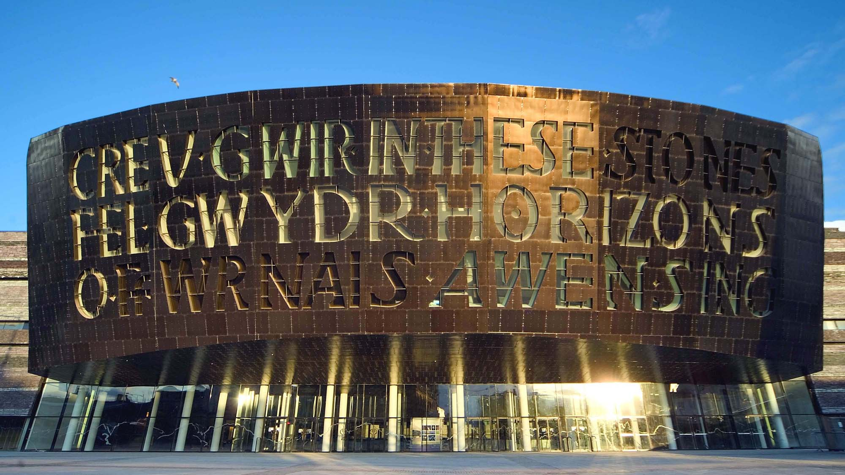
TGAU
Enw: ……………………….
Dosbarth: ………………….
Enw: …………………………………
Top Tips…
- There is only one mistake in each exercise;
- K, Q, V, X, Z aren’t in the Welsh alphabet;
- Use a dictionary to check spellings;
- Remember the order of words in a Welsh sentence can be different from an English sentence e.g. bachgen dawnus (literally…‘boy talented’);
- Don’t rely too heavily on Google Translate…it isn’t always correct…

Ymarfer 1 – enwau gwledydd |  |  | Ymarfer 2 – tywydd
Gwall  Mistake | Cywiriad  Correction |  | Gwall  Mistake | Cywiriad  Correction
Cymry (Wales) |  |  | byrw glaw (raining)
Loegr (England) |  |  | bwrw eria (snowing)
Iwerdon (Ireland) |  |  | stormys (stormy)
Yr Alba (Scotland) |  |  | gwuntog (windy)
Frainc (France) |  |  | heilog (sunny)
Ffrangeg (France) |  |  | nywlog (foggy)
Spaen (Spain) |  |  | brav (fine)
Yr Almean (Germany) |  |  | divlas (miserable)
Y Eidal (Italy) |  |  | cynes (warm)
america (America) |  |  | pwyth (hot)

Ymarfer 3 – teithio |  |  | Ymarfer 4 – rhannau’r corff
Gwall  Mistake | Cywiriad  Correction |  | Gwall  Mistake | Cywiriad  Correction
ty (house) |  |  | gwalt (hair)
pabel (tent) |  |  | lygaid (eye)
gweli a brecwast (bed & breakfast) |  |  | clist (ear)
gwesti (hotel) |  |  | danedd (teeth)
caravan (caravan) |  |  | ysgwyth (shoulder)
awyrenn  (aeroplane) |  |  | cevn (back)
long (ship) |  |  | cois (leg)
cooch (boat) |  |  | treod (foot)
gwylio (holidays) |  |  | tread (feet)
teitho (travel) |  |  | corf (body)

Ymarfer 5 – anifeiliaid |  |  | Ymarfer 6 – ystafelloedd
Gwall  Mistake | Cywiriad  Correction |  | Gwall  Mistake | Cywiriad  Correction
ki (dog) |  |  | ystafel (room)
key (dog) |  |  | lollfa (lounge)
ceffil (ceffyl) |  |  | cegyn (kitchen)
mochen (pig) |  |  | ystafell weli (bedroom)
niedr (snake) |  |  | ystafell ymolci  (bathroom)
bywch (cow) |  |  | cynedd (hall)
daffad (sheep) |  |  | swydfa  (office/ study)
mochen cwta  (guinea pig) |  |  | shed (shed)
bocdew  (hamster) |  |  | gard (garden)
pyscodyn aur  (goldfish) |  |  | gareg  (garage)

Ymarfer 7 – cyfleusterau’r ardal |  |  | Ymarfer 8 – cymalau dw i’n
Gwall  Mistake | Cywiriad  Correction |  | Gwall  Mistake | Cywiriad  Correction
pŵl nofio (swimming pool) |  |  | Dw in (I/ I am)
pwll novio (swimming pool) |  |  | Dw i’n hofi (I like)
cinema (cinema) |  |  | Dw i’n mywnhau  (I enjoy)
ysgol gynrad (primary school) |  |  | Dw i wrth fy mod  (I love)
cafi (café) |  |  | Dw i’n gwirion ar  (I love)
ferm (farm) |  |  | Dw i’n cari  (I love)
byd nature  (nature) |  |  | Dw i’n medwl  (I think)
cefn gwladd  (coruntryside) |  |  | Dw i’n credi  (I believe)
avon  (river) |  |  | Dw i’n teimllo  (I feel)
mynyddoed  (mountains) |  |  | Dw i’n cutuno  (I agree)

Ymarfer 9 – y/ yr |  |  | Ymarfer 10 – berf amodol (hoffi)
Gwall  Mistake | Cywiriad  Correction |  | Gwall  Mistake | Cywiriad  Correction
yr llyfr |  |  | hofwn i  (I would like)
yr cas pensil |  |  | hofet ti  (you would like – sing.)
yr pensil |  |  | hoffai i  (he would like)
yr pen |  |  | hoffa hi  (she would like)
yr rwbiwr |  |  | hoaffen ni  (we would like)
yr pren mesur |  |  | hofec chi  (you would like – pl.)
yr cwmpawd |  |  | hoffen Ni  (we would like)
y onglydd |  |  | Hoffoon i fynd i Co-op.  (I would like to go to Co-op.)
yr pensiliau lliw |  |  | Hoffai i brynu esgidiau newydd i’r parti. (She would like to buy new shoes for the party.)
yr dyddiadur gwaith cartref |  |  | Hoffen i aros mewn gwesty. (We would like to stay in a hotel.)

Ymarfer 11 – atalnodi (punctuation)
Gwall  Mistake | Cywiriad  Correction
Ble mae Caerdydd
(Where is Cardiff?)
Mae lois yn caru coginio.
(Lois loves cooking.)
Wyt ti’n byw yn Llanidloes?”
(“Do you live in Llanidloes?”)
Mae Bangor yng Ngogledd Cymru
(Bangor is in North Wales.)
Hoffwn i fod yn athro Cymraeg
(I would like to be a Welsh teacher!)
Basai o’n hoffi mynd i Roeg ym mis awst.
(He would like to go to Greece in August.)
Beth yw dy farn di am ysmygu
(What is your opinion on smoking?)
“Ble mae Llion yn byw?
(“Where does Llion live?)
Ces i fy ngeni ar Ddydd Llun, 8fed Tachwedd.
(I was born on Monday, 8th November.)
Mae’r gwyliau haf yn dechrau ym mis gorffennaf.
(The summer holidays start in July.)

Ymarfer 12 –  to bach/ acen grom |  |  | Ymarfer 13 – cystrawen
Gwall  Mistake | Cywiriad  Correction |  | Gwall  Mistake | Cywiriad  Correction
mor (sea) |  |  | Dw i’n cael…  (I have…)
nôs (night) |  |  | Fi ddim yn cael…  (I don’t have)
nol (back) |  |  | gyd o’r plant  (all the children)
hâf (summer) |  |  | rhai weithiau  (sometimes)
tê (tea) |  |  | rhy gormod  (too much)
ty (house) |  |  | Fi ddim yn hoffi  (I don’t like)
tô (roof)
can (song)
cor (choir)
gret (great)

Ymarfer 14
Gwall  Mistake | Cywiriad  Correction
Mae gan i gath a ci.
(I have a dog and a cat.)
Mae gen ti frechdan ham i gunio.
(You have a ham sandwich for lunch.)
Mae ganddo fo wallt dye, cyrliog.
(He has black, curly hair.)
Mae ganddi hi gi bac.
(She has a puppy.)
Mae gan Sam dri brawdd.
(Sam has tri brothers.)
Mae gan Llinos gacen bemblwydd.
(Llinos has a birthday cake.)
Mae gennyn ni lawer o waith cartref
Mathamateg.
(We have lots of Maths homework.)
Mae gennych ci apwyntiad yn y bore.
(You have an appointment in the morning.)
Mae ganddyn nhw deulu marw.
(They have a large family.)
Mae gen i flodau pink yn yr ardd.
(I have pink flowers in the garden.)

Ymarfer 15 – does gen i ddim
Gwall  Mistake | Cywiriad  Correction
Does gen i ddim gwaith cartef!
(I don’t have any homework!)
Does gen I ddim brawd.
(I don’t have a brother.)
Does gen i dim syniad.
(I don’t have a clue.)
Dos gen i ddim chwaer.
(I don’t have a sister.)
Does ganddo fo ddim ymarfer rygby.
(He hasn’t got rugby training.)
Does gandi hi ddim sesiwn nofio heno.
(She hasn’t got a swimming session tonight.)
Does gennyn ni ddim brechdanau i gino.
(We don’t have sandwiches for lunch.)
Does gen i ddim frindiau sy’n byw yn y De.
(I don’t have friends who live in the South.)
Does gando fo ddim siocled yn ei boced!
(He doesn’t have any chocolate in his pocket!)
Des ganddi hi ddim awydd mynd i Lerpwl.
(She has no desire to go to Liverpool.)

Ymarfer 16 – yn fy marn i
Gwall  Mistake | Cywiriad  Correction
Yn fi marn i, mae gwyliau yn wastraff amser!!
(In my opinion, holidays are a waste of time!!)
Y fy marn i, mae canu yn dda i bobl ifanc.
(In my opinion, singing is good for young people.)
Yn fy marn I, mae’n bwysig edrych yn daclus.
(In my opinion, it’s important to look tidy.)
Yn fy marn i, mae hufen iâ yn well na siochled.
(In my opinion, ice cream is better than chocolate.)
Yn fy marn i, mae cŵn Jack Russell yn ciwt!
(In my opinion, Jack Russell dogs are cute!)
Yn fy marn i, bydd Cymru yn enill Cwpan Y Byd!
(In my opinion, Wales will win the World Cup!)
Yn fy marn i, ma cerddoriaeth glasurol yn ymlaciol.
(In my opinion, classical music is relaxing.)
Yn fy marn i, dylai pobl ifanc ddysgu sarad mwy o ieithoedd.
(In my opinion, young people should learn to speak more languages.)
Yn fy marn i, mae gwaith catref yn wych! (Jôc!!)
(In my opinion, homework is great! (Joke!!))
Yn fy marn i, golf ydy’r chwaraeon gorau yn y byd i gyd!
(In my opinion, golf is the best sport in the whole wide world!)

Ymarfer 17 – a/ ac
Gwall  Mistake | Cywiriad  Correction
Mae cath ac ci yn byw yn y tŷ.
(A cat and dog live in the house.)
Mae Gwen wrth ei bodd yn chwarae rygbi ac pêl-droed.
(Gwen is very fond of playing rugby and football.)
Mae cwpan ac soser ar y bwrdd.
(There is a cup and saucer on the table.)
Mae fy nhaid yn bwyta bacwn a wy i frecwast.
(My Grandad eats bacon and egg for breakfast.)
Rydyn ni’n mynd i Gaer a Amwythig yn y gwyliau.
(We’re going to Chester and Shrewsbury in the holidays.)
Wyt ti’n hoffi Cerddoriaeth ac Drama?
(Do you like Music and Drama?)
Mae Mam yn siopa yn y cigydd a yn y farchnad leol.
(Mum shops in the butchers and in the local market.)
Mae blodau ac llysiau yn tyfu yn yr ardd.
(Flowers and vegetables are growing in the garden.)
Pwy sydd eisiau bwyta reis ac pasta?
(Who wants to eat rice and pasta?)
Ydych chi wedi darllen nofelau T. Llew Jones ac nofelau Irma Chilton?
(Have you read the novels of T. Llew Jones and the novels of Irma Chilton?)

Ymarfer 18 – 3ydd person unigol
Gwall  Mistake | Cywiriad  Correction
Ma o’n hoffi bwyta pasta a ionod.
(He likes eating pasta and onions.)
Mae i’n mynd i ysgol newydd ym mis Medi.
(She is going to a new school in September.)
Mae Catrin yn gobeithio mynd i wylio gem rygbi Cymru yn erbyn Lloegr.
(Catrin hopes to watch a rugby game Wales versus England.)
Roedd o byw yng Nghaerdydd.
(He lived in Cardiff.)
Rodd hi’n darllen llawer o lyfrau.
(She read lots of books.)
Roedd huw yn gweithio’n galed.
(Huw was working hard.)
Bydd o’n gyru car coch.
(He will be driving a red car.)
Byd hi’n cael sioc wythnos nesaf!
(She will have a shock next week!)
Bydd Lisa’n symyd i Seland Newydd.
(Lisa will be moving to New Zealand.)
Hoffai o chwarae rygby dros Gymru.
(He would like to play rugby for Wales.)

Ymarfer 19 – y gorffennol
Gwall  Mistake | Cywiriad  Correction
Es I I Aberdyfi. (I went to Aberdovey.)
Rhedod Wil yn gyflym. (Wil ran quickly.)
Meddylodd Ffion. (Ffion thought.)
Tafflodd Geraint y bêl.
(Geraint threw the ball.)
Cyssgodd Twm yn drwm.
(Twm slept heavily.)
Aeth i i siopa. (He went shopping.)
Aethoc chi i’r caffi. (You went to the café.)
Nofiais ni yn y pwll newydd.
(We swam in the swimming pool.)
Arhosais ni mewn pabell pinc.
(We stayed in a pink tent.)
Ysgrifennais i ar y bwrdd gwyn.
(We wrote on the whiteboard.)

Ymarfer 20 – Pa?
Gwall  Mistake | Cywiriad  Correction
Pa mor aml wyt ti’n mynd i’r Dreneywdd?
(How often do you go to Newtown?)
Pa mora ml wyt ti’n cael gwaith cartref?
(How often do you have homework?)
Paa mor aml wyt ti’n cerdded i’r ysgol?
(How often do you walk to the school?)
Pa more aml wyt ti’n bwyta llysiau a ffrwythau?
(How often do you eat vegetables and fruit?)
Pa mor aml wyt ti’n gneud ymarfer corff?
(How often do you do exercise?)
Pa siocled yw dy hoff in?
(Which chocolate is your favourite one?)
Pa frwyth yw dy hoff un?
(Which fruit is your favourite one?)
Pa bwnc yw dy hoff bwc?
(Which subject is your favourite subject?)
Pa ddydd yw dy gas ddydd
(Which is your least favourite day?)
Pa chwaraeon yw dy gas chwaraeoon?
(Which sport is your least favourite sport?)

