a) Draw and label an animal cell  Topic 1 – Cells and movement across cell membranes | b)Label a plant cell  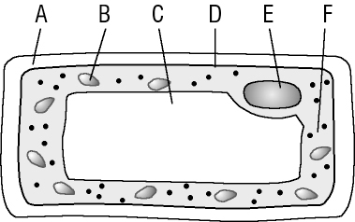 |  | C) what is the function of:  Nucleus  Cell membrane  Cell wall  Cytoplasm  Chloroplasts  Vacuole  Mitochondria
Microscopes type advantages disadvantages  Stain used for:  Plant cells-  Animal cells- | e) magnification  eyepiece lens x objective lens = magnification  Rules of drawing from a microscope slide:  List specialised cells  i. ii. iii. |  | Definition Examples  tissue  Organism  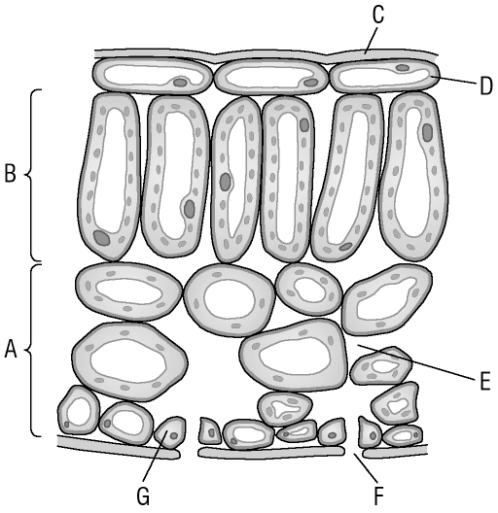  Label inside a plant leaf:
g) Diffusion  How can we change the rate of diffusion?  How do we model diffusion in the lab? | h) Osmosis  Active transport |  | i) Enzymes – definition-  effect of temperature and pH-  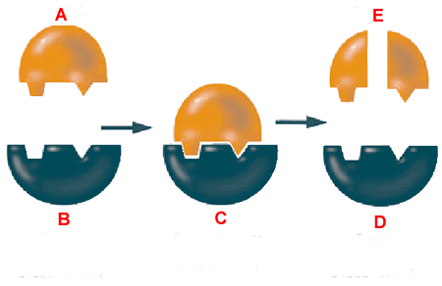  Specified Practical: best temperature to wash clothes

